FIM RALLY 2026
SUPPLEMENTARY REGULATIONS
APPENDIX

Program
IMPORTANT NOTE – Check-in to hotels is after 15:00h!

24.05.2026 – Sunday
- 08:00 – 19:00 Welcome Desk & Registration of participants at the Arrival Center (check-in to hotels after 15:00h)
- 10:00 – 16:00 Arrival Ceremony
- 19:30 – 21:30 – Dinner & Opening Ceremony
- 21:30 – Drinks and socializing in the Tavern & the Camping Bar

25.05.2026 – Monday
- 07-00 – 8:30 – Breakfast
- 9:00 – 16.00 – Main Excursion – MOT.O.E Trophy – a Game of FUN - Observation and Adventure that will lead you around the island and reward you with great gifts and trophies.
- Lunch will be served on various checkpoints during Excursion
- 19:30 – 21:30 Dinner & 1st Award Ceremony (Interclubs, Junior Meritum,…)
- 21:30 – Drinks and socializing in the Tavern & Camping Bar

26.05.2026 Tuesday
- 07.00-08.30 Breakfast
- 10:00-11:00 Arrival to the “Grouping Location” for the Parade of Nations
- 11:00-12:00 Parade of Nations
- 12.00 – 16.00 Free time in the City of NAXOS
- 19:30 – 21:30 Dinner & 2nd Award Ceremony (FIM Challenges)
- Closing Ceremony
- 21:30 – Drinks and socializing in the Tavern & Camping Bar

27.05.2026 Wednesday
- 07.00 – 0830 Breakfast
- 09.00 Goodbyes

Early Arrivals Program – Optional Excursions
We, the Organising Team, will be thrilled to accommodate participants well before the official opening of the event.
Camping and Hotels will be available to participants at the rates as indicated in the Participation Form. Theses early arrivals will have a choice of either relaxing and chilling out in their chosen accommodation, or participate in organised activities and ride-outs around the island.

20.05.2025 – Wednesday
3 Motorcycle Games in intresting locations around the island. – 35€ (includes coffee brake + lunch or lunch box, plus prizes for the first three)
21.05.2025 – Thursday
A. Tarmac Ride out to the Island’s inland, visit the villages of Xalkeion & Apeiranthos and Museums –35 € (includes coffee brake +lunch or lunch box)
B. Soft off-road ride-out on non tarmac roads that lead to beautiful, untouched beaches – 35 € (includes coffee break + lunch or lunch box)
22.05.2026 – Friday
- 07-00 – 8:30 – Breakfast
- Optional Cruise 1 to Delos & Mykonos. Participants will be taking a 3 hour tour of the Delos Archaeological site and then transferred to Mykonos where they can stroll around the beautiful waterfront and picturesque alleys and enjoy their lunch in one of the traditional taverns of their choice.
Delos, the entire island is designated as an archaeological site, to be precise, a UNESCO world heritage site. It’s an ark of history, floating lazily on the waters of the Aegean Sea, just a few miles away from cosmopolitan Mykonos. It’s a chance to walk around the revival of the glory of Greek civilization. It’s the head priest of the Cyclades, the birthplace of the immortals. It’s Delos.
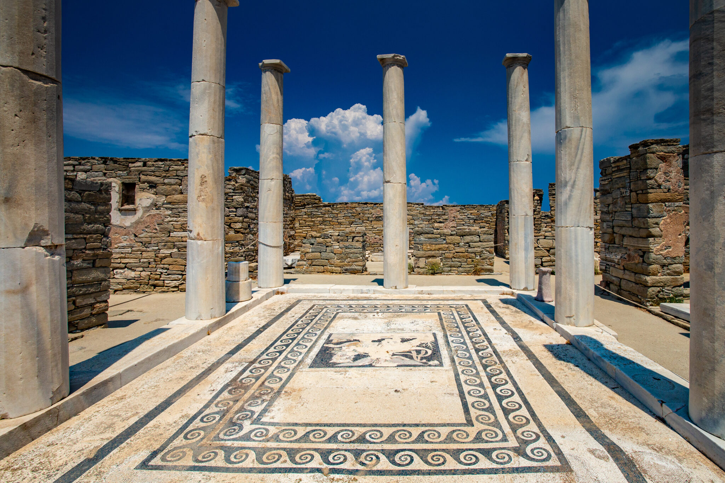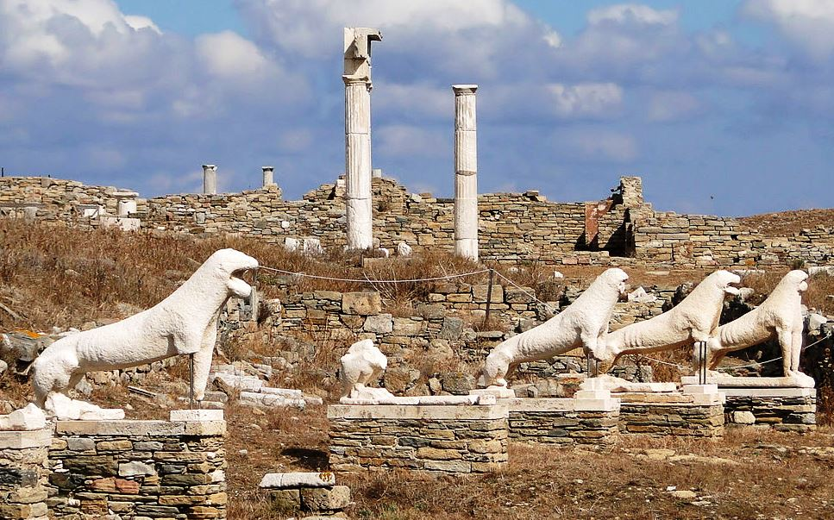
Mykonos is…. Mykonos, the island of Beauty and Magic.
125 € per person including Transfer from Hotel or Camping to and from Naxos Harbour: https://maps.app.goo.gl/28FX63m2ZMuSaVYS6

23.05.2026. - Saturday
- 07.00-08.30 Breakfast
- Optional Cruise 2 to Koufonisia islands
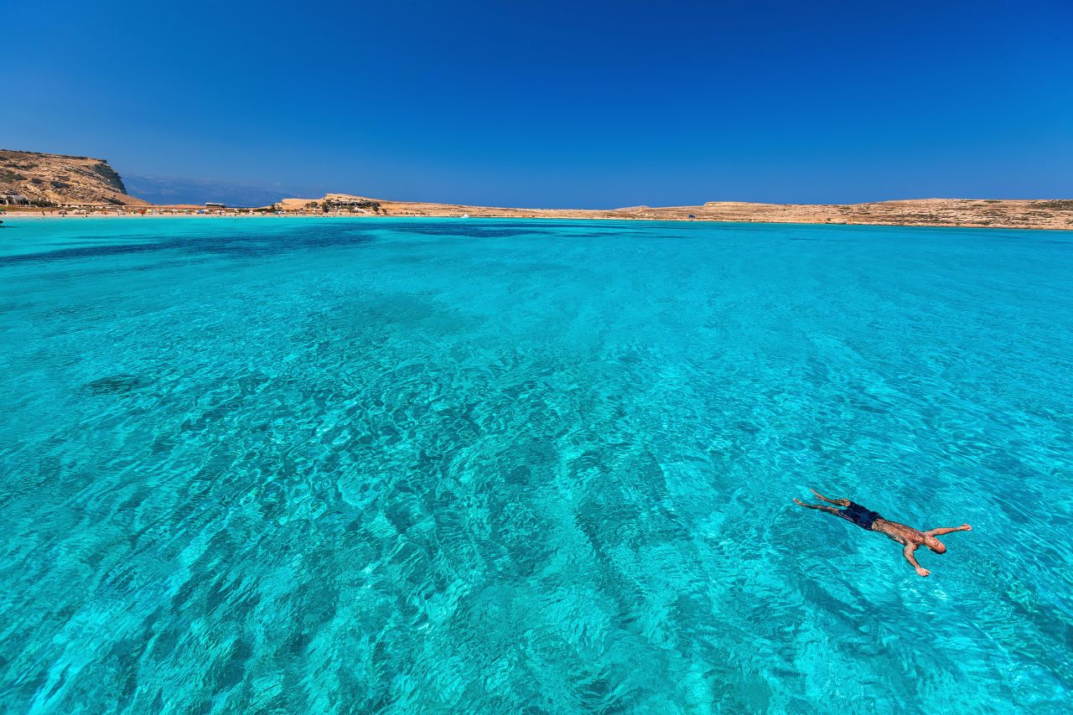
Koufonisia is a complex of small islands with white sandy beaches and emerald seas. Participants will have the chance to bathe in the crystal-clear waters and sunbathe under the Aegean sun. Traditional dishes will be served for lunch.
09.45 Departure from Agia Anna Harbour
10.30 Breakfast on board – Warm bread with tomatoes and graviera cheese (Produced in Naxos)
11.15 Rina’s Cave (45 min for swim)
12.30 Kato Koufonisi (unihabited) Swim & B.B.Q. (wine & refreshments included)
14.10 Departure for Ano Koufonisi, 14.30 arrival, disembarkation, 2.00 hours free time
17.00 Return departure, fresh fruits served on board
19.15 Return at Agia Anna Harbour
Drinking water throughout the cruise and the lunch wine and refreshments are included in the price. Other drinks available on demand at the bar.
110 € per person including transfer from Hotel or Camping to and from the Agia Anna Harbour: https://maps.app.goo.gl/ibQW9trFKxo4nLzY8
Accommodation and Ferries Information
HOTELS
- CATEGORY 1: 100 € per double room per night / (Single or Double use)
- CATEGORY 2: 110 € per double room per night / (100 € per night for single use)
- CATEGORY 3: 125 € per double room per night / (115 € per night for single use)
- CATEGORY 4: 170 € per double room per night / (160 € per night for single use)
CAMPING
25 € per person per day including breakfast
Also available are a few Bedtents for two persons in the Camping ground at 30 € per person/per day and also the possibility of renting a tent at 30 € per tent/per day. You can book these ONLY after previously checking the availability with the Organiser.
FERRIES
Piraeus / Naxos / Piraeus (Round Trip)
- Person: 105.00 €
- Motorcycle: 65 €
- Car: 235.00 €
- Van up to 4,5m: 280 €
- Camper: – 300 €
PS: These prices are valid at this moment (January 2026). In case of a change in ferry prices, there will also be a change in prices here.
FOR FERRIES FROM ITALY, we suggest to contact our travel partner ZAS TRAVEL, here: https://zasferries.com/
FERRIES IMPORTANT NOTICE
If you purchase your ferry tickets via the event Entry Form (through MOT.OE) you will receive the collectible SOFTCELL POLO JACKET by NORDCODE: https://www.motomarket-shop.gr/en/for-rider/clothing/jackets/winter/19311-nordcode-polo-oversize-softshell-jacket-en1621-grey
to be delivered to you at the Arrival Centre.
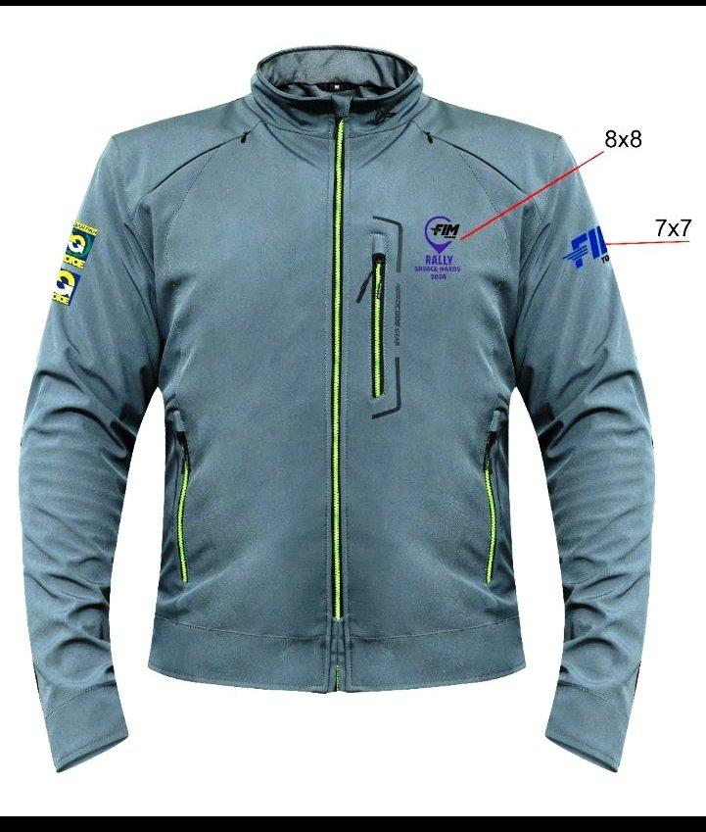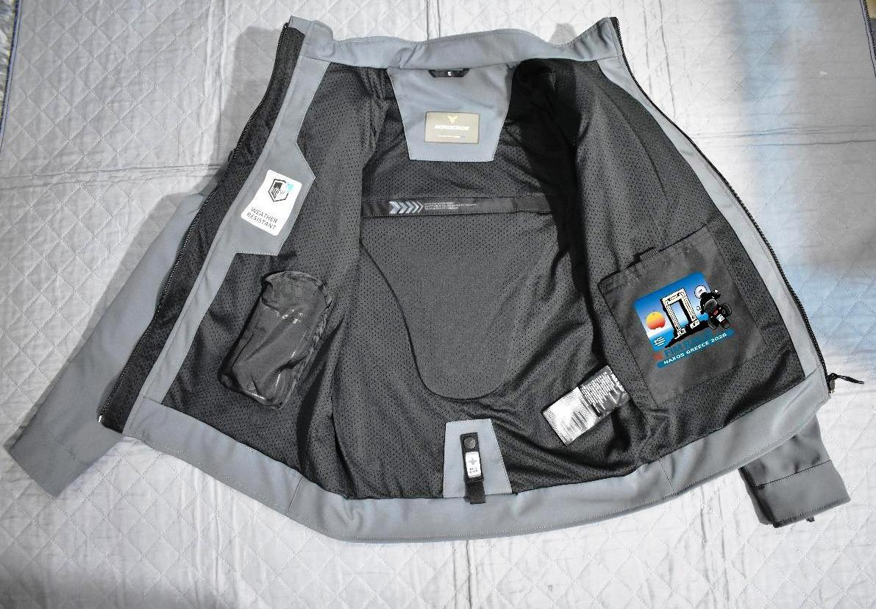

MOTORCYCLE RENTAL
To facilitate FLY & RIDE Participants, the Organiser has arranged priviledged treatment of participants on Bike or Scooter Rental, either in Athens or Naxos.
In Athens or Naxos: https://andelimototouring.gr/en/home/
In the Island of Naxos: https://www.facebook.com/NaxosOnTheRoad/

